Formation of ZnO Nanorods for Improving Color Stability of Wood

Yu Yan ¹ Song Ye ^{1, 2} Wang Ge ¹

1. International Center for Bamboo and Rattan, Beijing, China
2. Central South Forestry Science and Technology University, Chang Sha, Hunan
E-Mail Address: yuyan@icbr.ac.cn

Introduction
It has been widely known that wood exposed to solar radiation is subject to surface discoloration, which will seriously limit the outdoor application of wood-based products ^{[1]}. Various approaches, including chemical modification, protective finish and so on, have been adopted to improve the photo stabilization of wood. Here we reported a new method for wood color protection, which is characterized with forming ZnO Nanorods films on the surface of wood via a low temperature aqueous solution route. The results indicated the photostabilization of modified wood has been greatly improved.
Materials and Methods
Chinese Fir was selected for the present research because of its abundant resources in China. Wood block with 10 mm (R)*10mm (T) * 20 mm (L) was firstly treated in the ZnO nanosol at 60℃ for 0.5 h, 1 h, 2 h and 4 h. The ZnO nanosol was prepared by adding zinc acetate dehydrate and NaOH into 1000 mL methanol and stirred for 2 h^{[2]}. After that the sample was immersed in a solution of zinc nitrate hydrate (0.025 M) and methenamine (0.025 M) at 90 ℃ for 6 h, and then dried at 60 ℃ for 3 h.
A field-emission scanning electron microscope (XL30-ESEM, FEI) was used to examine the surface morphology of the sample. A weather-0-meter (Atlas, Germany) was used to accelerate the photo discoloration of the wood sample. The change in color of wood surface was measured with a color meter (BYK-6834，Germany).
Results and Discussion
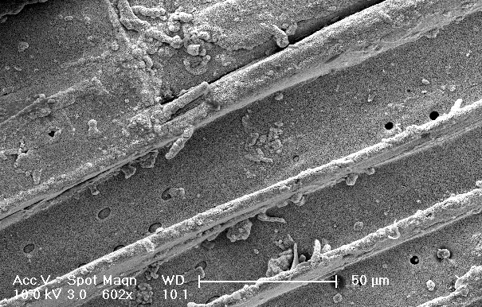
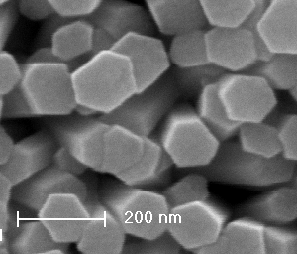
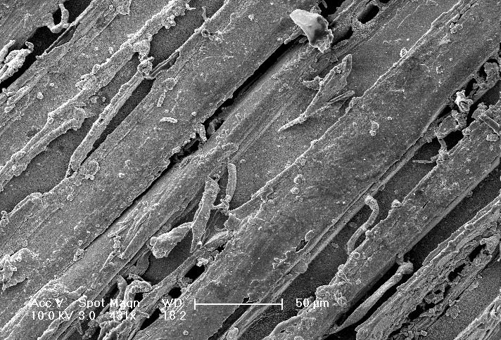
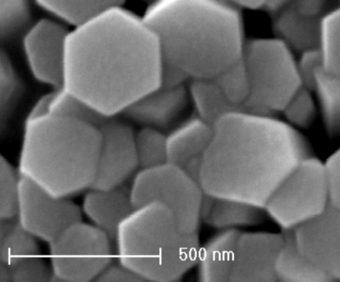
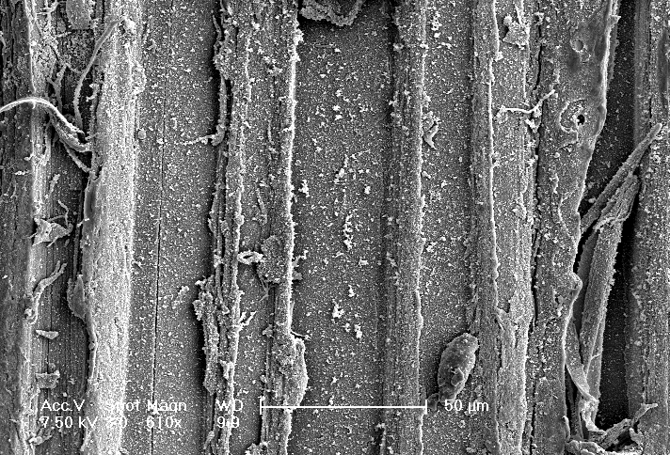
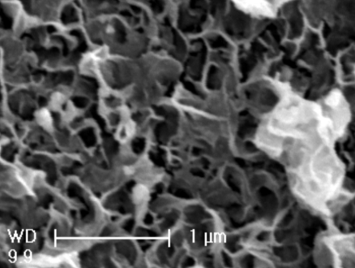
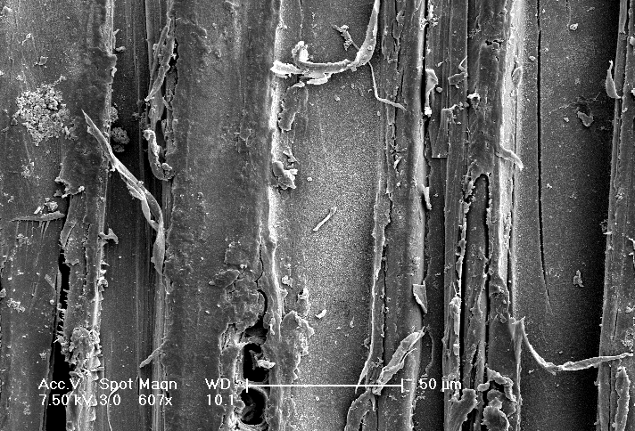
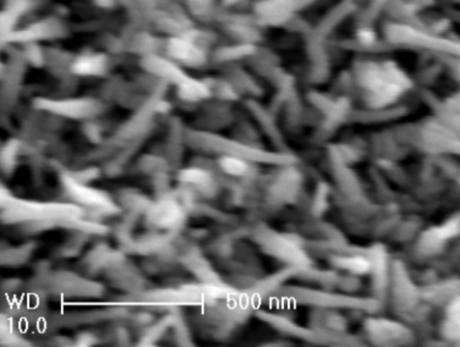
A
B
C
D
A

Fig.1 SEM images of the tangential surface of wood immersed in ZnO nanosol for different time: A 0.5 h; B 1 h; C 2 h; D 4h. Each image was inserted with a high magnification one
Fig.1 indicated ZnO nanorods array with well-defined hexagonal end faces formed on the surface of wood treated in ZnO nanosol for 0.5 h and 1 h (Fig.1 A-B). The diameter of ZnO nanorods ranged from 70 nm to 170 nm for the sample immersed in the ZnO nanosol for 0.5 h, while 100 nm to 350 nm for 1 h. Network structure composed of irregular nanorods will forme if the immersion time increased to 2 h and 4 h (Fig.1 C-D).
Fig.2 the color stability of wood treated in the ZnO nanosol with different time
In the CIELAB system, L* represents lightness, a* and b* are chromaticity coordinates. △L*, △a* and△b* are the difference of initial and final values (before and after irradiation), which can be used to calculate the overall color changes△E*^{[3]}. A low △L*, △a*,△b* and △E* value corresponds to higher color stability. Fig.2 indicated △L*, △a*,△b* and △E* of the treated samples are all significantly less than that of the control ones, which proved ZnO modification could improve photostabilization of wood. Furthermore, the immersion time in the ZnO nanosol will affect the efficiency of color protection. The color stability of wood treated for 0.5 h and 1 h are better than that of 2 h and 4 h, which indicated the ZnO nanorod array plays an important role in the solar discoloration of wood.

Acknowledgement
The present research was financially supported by the 11th Five Years Key Technology R&D Program of China (project number: 2006BAD19B05)
References
[1] Derbyshire1 H, Miller R. The photodegradation of wood during solar irradiation. Part I: Effects on the structural integrity of thin wood strips. Holz als Roh- und Werkstoff, 39(8), 1981.
[2] Vayssieres L. Growth of arrayed nanorods and nanowires of ZnO from aqueous solutions. Advanced Materials, 2003, 15(5):464-466.
[3] Pandey K. P. Study of the effect of photo-irradiation on the surface chemistry of wood. Polymer Degradation and Stability. 2005, 90: 9-20

